NiMAP toolkit for companies

Exercise leaflets

This overview of exercise leaflets is designed by Vlerick Business School and Talentree with the support of the European Social Fund and the Flemish Government to help organisations in creating a diverse and inclusive work environment. It is part of the training toolkit for companies, which is based on learnings we gathered during a project focused on guiding highly-educated newcomers and companies to fasten the job search and induction process on the workfloor. The training toolkit consists of 4 modules, designed for companies looking to diversify their talent pool:

- module 1: Multicultural Diversity on The Agenda
- module 2: Building a Diverse organisation: Getting The Foundations Right
- module 3: Recruiting for Diversity
- module 4: Managing Diversity in The Workplace

The modules are designed in such a way companies can use them autonomously to set up their own diversity initiatives and workshops. Each module consists of:
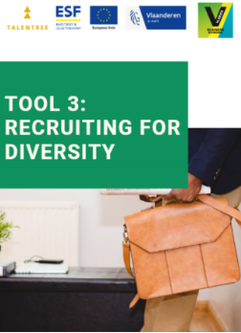
- a tool
- an interactive PowerPoint presentation
- detailed leaflets of each exercise referred to in the PowerPoint presentation by a blue dotted background
This document combines all exercise leaflets per module.

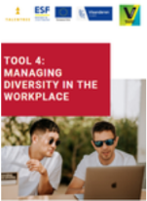
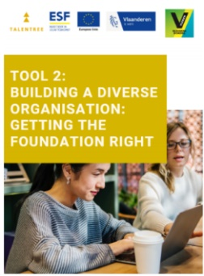
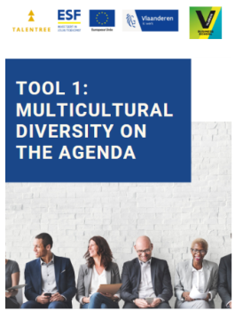

TABLE OF CONTENTS

MODULE 1: Multicultural diversity on the agenda 1
1.1. TOUR DE TABLE 2
1.2. DIVERSITY QUIZ 4
1.3. WHY DIVERSITY MATTERS 6
MODULE 2: Building a diverse organisation: getting the foundations right 9
2.1. DEFINING STAKEHOLDERS 10
2.2. STAKEHOLDER GRID 12
2.3. FROM MONO TO INTERCULTURAL MINDSET 15
2.4. RIDDLES 18
2.5. TRUST BUBBLE 22
2.6. TESTIMONIAL ACCENTURE 25
MODULE 3: Recruiting for diversity 29
3.1. TACKLE BIAS BEFORE IT TACKLES YOU 30
3.2. CV SCREENING 32
3.3. PERSONAL GOALS 35
3.4. TESTIMONIAL CITY OF GHENT & PUBLIC CENTER FOR SOCIAL WELFARE GHENT 38
MODULE 4: Managing diversity in the workplace 42
4.1. CODE OF CONDUCT 43
4.2. DO’s AND DON’ts 46
4.3. FLAWLESS FEEDBACK 49
4.4. I AM BUT I AM NOT 51
4.5. ROLE PLAYS 54
4.6. DILEMMA DEBATE 62
4.7. GINGER MAN 71
4.8. EMPATHY MAP 74
CONTACT US 80

MODULE 1

Multicultural diversity on the agenda

  - TOUR DE TABLE
PRACTICAL GUIDELINES
Objectives | - Helping participants to get to know each other  - Breaking the ice
Target group | A team getting started with the NiMAP material, which consists of participants who don’t know each other yet
Number of participants | Big audience
Duration | 15 minutes
Set-up | Material:  - A small ball

INSTRUCTIONS
Welcome to this diversity workshop. Before we get started, it’s important we get to know each other a little bit better. Let’s do this using this ball.
Let’s stand up and form a circle.

EXERCISE
Give the ball to one person and ask this person to introduce him or herself saying their name, background, expectations of the workshop and personal experiences with diverse/non-diverse teams and workplaces.
Then ask this person to throw the ball to someone else, who’s next to introduce him or herself.
Continue until everyone has had a turn.

  - DIVERSITY QUIZ
PRACTICAL GUIDELINES
Objectives | - Introduction to the topic diversity: setting the scene  - Learning some interesting facts and numbers
Target group | - A team or company that wants to direct its attention to diversity in a playful way
Number of participants | Big audience
Duration | 20 minutes
Set-up | Material:  - Quiz (presented in PowerPoint presentation or online quiz tool)  - Available in Kahoot! via link below:  https://create.kahoot.it/share/diversity-quiz/1cd86418-dd73-47b2-9903-7b20c309ac18  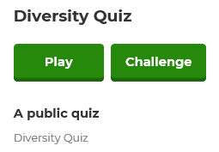  - Choose “Play”  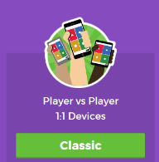  - Choose “Classic”  - Pin code will appear

INSTRUCTIONS
We will now do a diversity quiz. This quiz aims at setting the scene for further discussion on diversity.
Please all go to https://kahoot.it/ & enter the pin code (cfr. Practical Guideline - Set-up). Choose a nickname, click “OK, go!” and wait for the others to register.

QUIZ
Once everyone has entered the game (all the nicknames have appeared on the screen), the quizmaster chooses “play” to start the quiz.
Quizmaster goes through all the questions (n = 8).
After each question, quizmaster gives the right answer and provides a bit of context / background information. This information can be found in the PowerPoint presentation of tool 1.
Kahoot automatically calculates (based on the number of correct answers and speed) who’s the winner of the quiz.

DISCUSSION
Ask participants:
- What they have learned
- Which answers they found surprising
Congratulate the winner

  - WHY DIVERSITY MATTERS
PRACTICAL GUIDELINES
Objective | Reflecting on why diversity matters for companies based on personal experiences
Target group | A team or company that wants to put multicultural diversity higher on the agenda
Number of participants | Divide the group into subgroups of +/- 4 people and conduct the discussion with the entire group
Duration | 15 minutes
Set-up | Material:  - Flipchart  - Template (cfr. Attachment I)

INSTRUCTIONS
To get multicultural diversity on the agenda, it’s important to know the reasons why companies should invest in diverse workplaces.
Let’s all take 5 minutes to think about possible advantages when investing in diversity. Also, think the other way around: what could be risks for companies if they refuse to invest in diverse teams? Try to list at least 5 advantages and 5 risks.

EXERCISE
Form subgroups of +/- 5 persons and ask each group to list at least 5 advantages and 5 risks. Participants can first do this individually, using the template in attachment I, and put their answers together later on.
Let each subgroup present their lists of advantages and risks using a flipchart.

DISCUSSION
Some guiding questions to stimulate discussion during the presentations:
- Do the other groups agree with the presented advantages and risks?
- Who’s affected by this specific risk?
- Who benefits from this specific advantage?
- Which advantages/risks play in the short-term?
- Which advantages/risks play in the long-term?
- …

ATTACHMENT I

Why diversity matters

Advantages when investing in diversity
Risks when not investing in diversity

MODULE 2

Building a diverse organisation: getting the foundations right

  - DEFINING STAKEHOLDERS
PRACTICAL GUIDELINES
Objectives | - Reflecting on why companies should invest in diversity
Target group | A team that wants to invest more in diversity and needs to get the whole company on board.
Number of participants | Ideally 8 – 30 people  Exercise can be done with the entire group  It’s also possible to divide the group into subgroups of +/- 4 people and conduct the discussion with the entire group
Duration | 15 minutes
Set-up | Material:  - Flipchart

INSTRUCTIONS
Who are the most important stakeholders to get on board when introducing a new diversity initiative? Think about who you need by your side to make things work.

DISCUSSION
Write down all the stakeholders the participants mention (use a flipchart).
Questions to ask with regard to each stakeholder:
- Why it’s important to convince this stakeholder?
- What could be sources of resistance?

  - STAKEHOLDER GRID

PRACTICAL GUIDELINES
Objectives | - Linking diversity to positive organisational outcomes  - Thinking about how different stakeholders can be convinced to invest in diversity  - Prioritizing which stakeholders need to be convinced first
Target group | - A team that wants to convince one or more stakeholders to invest in diversity
Number of participants | Divide the group into subgroups of +/- 4 people and conduct the discussion with the entire group
Duration | 20 minutes
Set-up | Material:  - Stakeholder grid (cfr. Attachment I)  - Pens
Comment | This exercise builds upon leaflet 1.3. and leaflet 2.1., it’s possible to introduce the stakeholder grid already during the previous exercises (doing so, participants can include their output of these exercises into the grid and add output of leaflet 2.2. later on)

INSTRUCTIONS
Let’s use the following exercise to focus on the value of diversity for the different stakeholders.
You have 10 minutes to discuss with each other how the different stakeholders can be convinced. Focus on how an investment in diversity leads to positive organisational outcomes.
Divide the group into subgroups of +/- 4 people.
Each group chooses 2 stakeholders they want to convince in their company. Think about which of the listed arguments (benefits of investing in diversity and risks of not investing in diversity) might be useful to convince your stakeholder of choice to make them get on board of your diversity programme. Translate the arguments in concrete actions. Write down your answers in the grid.
First do this individually (on individual grids). Then share your ideas and write down the group answers in a shared grid.
Once you completed the grid, select the 3 highest priorities.

ROLE PLAYS
Each group now actually has to convince a stakeholder group. Therefore, appoint another subgroup to take on the role of the stakeholder of choice. The stakeholders have to be critical towards their persuaders (don’t take all the arguments for granted, ask critical questions!).
Make sure each group once takes on the role of persuader and once takes on the role of stakeholder.

DISCUSSION
Ask participants for their experiences:
- How did it feel to persuade?
- How did it feel to represent the stakeholder group?

ATTACHMENT I
 |  | Board/C-level | Line Management | HR  Recruitment | Corporate Citizenship | Employees | Unions
Benefits of investing diversity | Winning the war for talent
 | Strengthening customer orientation
 | Improving decision making and innovation
 | Increasing employee satisfaction
 | Enhancing the company’s image/CSR
Risks when not investing in diversity | Limited access to talent
 | Irrelevance
 | Turnover
 | Negative brand
 | Negative reactions

  - FROM MONO TO INTERCULTURAL MINDSET
PRACTICAL GUIDELINES
Objectives | - Discovering in which phase of inclusion your organisation can be situated  - Reflect one what your organisation can do to become more inclusive
Target group | A team that wants to reflect on the inclusivity level of their organisation
Number of participants | Individual exercise  Discussion should be conducted with the entire group
Duration | 15 minutes
Set-up | Material:  - Questionnaire (cfr. Attachment I)  - Pens

INSTRUCTIONS
Hand out the questionnaire and ask the participants to fill it in.

SCORING
Once everyone is finished, explain how to determine the phase of inclusion: “Count the score for each colour separately. When you have the highest score for the purple area, then your organisation is probably in the resistance phase. When you have the highest score for the orange area, you are probably in the conformity phase. The blue area reflects the inclusion phase, whereas the green area reflects the proactivity phase.”

DISCUSSION
Give a short explanation of the different phases: “Dass and Parker distinguished four phases of willingness within organisations: conformity, inclusion, proactivity and resistance, although when your organisation is situated in the resistance phase, your organisation is showing no willingness at all. Organisations in a resistance phase might react in a bad way to imposed diversity initiatives because they do not see the advantage of it. That is why it is so important to create first awareness in such organisations before taking action. Most Western organisations can be situated in the conformity phase: they follow societal developments without doing more than what is legally obliged. Organisations that chase a workforce that represents the ecological framework and that truly believe in the benefits of diversity, can be situated in the inclusion phase. Organisations in the proactive phase go even beyond this: they intervene in the organisational structure in order to accommodate diversity the best as possible. Such organisations believe that a diverse workforce is crucial for long-term growth.”
Discuss with each other whether or not you agree with your score and what you could do to become more inclusive.

ATTACHMENT I

 | 1  Strongly disagree | 2  Disagree | 3  Neutral | 4  Agree | 5  Strongly agree
Diverse managers are seen as a threat
Our organisation undertakes nothing to attract diversity
Our organisation is following the legal minimum
Diversity is primarily concerned as barrier
We are an example for other companies concerning our diversity policy
We are actively searching for ways to attract diversity
The management uses diversity as their trump card
The structure of the organisation is adapted to the needs of the different cultures
Questionnaire adapted from Dass & Parker (1999)

  - RIDDLES
PRACTICAL GUIDELINES
Objectives | - Experience biases  - Raise awareness on unconscious bias
Target group | A team that wants to reflect on diversity and unconscious biases towards people of foreign origin
Number of participants | Ideally 8 – 30 people  Exercise can be done with the entire group  It’s also possible to divide the group into subgroups of +/- 4 people and conduct the discussion with the entire group
Duration | 10 minutes
Set-up | Material:  - Riddles (cfr. Attachment I)  - PowerPoint slides of the exercises can be found in the PowerPoint presentation of module 2

INSTRUCTIONS
Fill in the exercises.

DISCUSSION
Present the solution of the exercise, using the PowerPoint slides 28-33 of the PowerPoint presentation of module 2. Solutions can be consulted in the notes of the slides.
Ask participants/subgroups:
- How they experienced the riddles?
- How they can explain wrong answers?
- How do biases influence our daily behaviour?
- …

ATTACHMENT I

Riddle 1

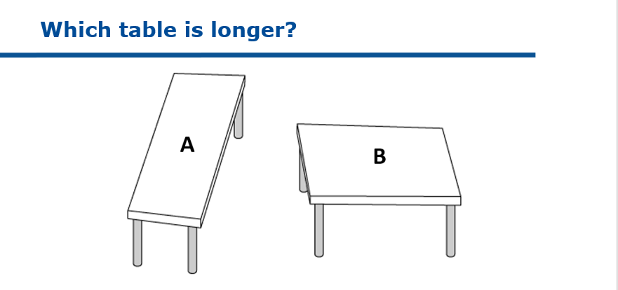

Answer: _________________________________________________________

Riddle 2

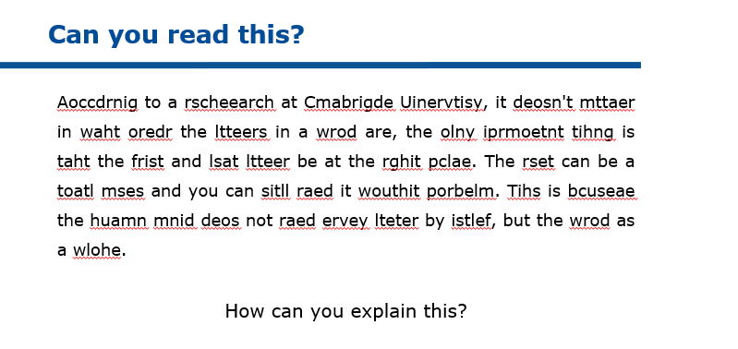

Answer: _________________________________________________________

Riddle 3
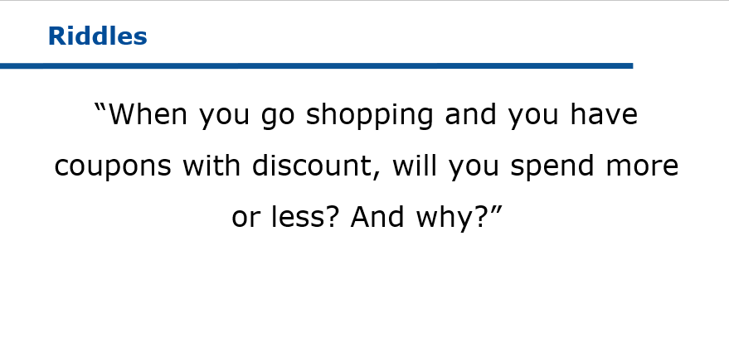

Answer: _________________________________________________________

Riddle 4
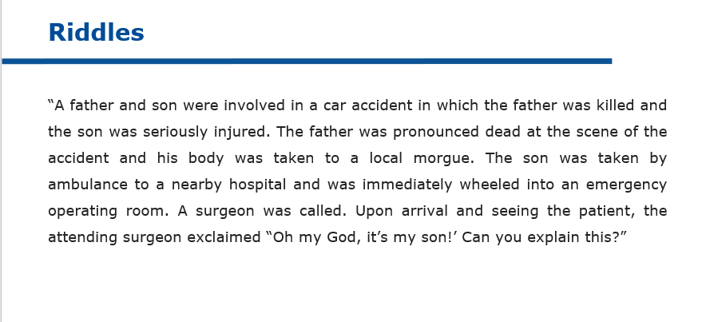

Answer: _________________________________________________________

  - TRUST BUBBLE

PRACTICAL GUIDELINES
Objectives | - Raising awareness on similarity attraction and affinity bias
Target group | A team that wants to reflect on diversity and unconscious biases towards people of foreign origin
Number of participants | Individual exercise  Discussion should be conducted with the entire group
Duration | 15 minutes
Set-up | Material:  - Form (cfr. Attachment I)  - Pens

INSTRUCTIONS
Fold the form in 2 in such a way participants can only see the first column: FIRST NAME.
Hand out the folded forms.
Ask participants to write down at least 5 people they trust blindly (who are NOT family members).
Then make everyone unfold the form so they see the other columns.
Ask everyone to fill in the other columns: what’s the gender, ethnicity, colour skin, age, profession, sexual orientation and educational background of the people they trust the most?

DISCUSSION
Below there are some guiding questions to start a discussion:
- Do you notice any tendencies?
- Who has at least 1 person on his/her list with a colour skin different from their own?
- Who has at least 1 person on his/her list with an ethnicity different from their own?
- …
How come the people we trust the most are so similar (to us)?

ATTACHMENT I
The Trust Bubble

FIRST NAME | GENDER | ETHNICITY | COLOUR SKIN | AGE | PROFESSION | SEXUAL ORIENTATION | EDUCATIONAL BACKGROUND
1.
2.
3.
4.
5.

  - TESTIMONIAL ACCENTURE

PRACTICAL GUIDELINES
Objectives | - Gaining insight in real business initiatives to get started with diversity initiatives
Target group | A team that wants to invest more in diversity and wants to get inspired by best practices of other companies
Number of participants | Divide the group into subgroups of +/- 4 people and conduct the discussion with the entire group
Duration | 15 minutes
Set-up | Material:  - Testimonial (cfr. Attachment I)

INSTRUCTIONS
When starting with diversity initiatives, companies can learn valuable lessons from each other. For this reason it’s important that companies share experiences, ideas, potential pitfalls,… with one another.
Read the case of Accenture and try to distil best practices, opportunities to implement similar initiatives in your organisation, potential pitfalls,… Focus on what you can learn from Accenture’s story.

DISCUSSION
Ask the group to share their takeaways.
Important learning lessons are:
- Ensure sponsorship of the executives
- Assign a changemaker/project owner
- Establish a joint vision why you do this
- Develop KPI’s
- Build ambassadorship
- Build a network of sourcing partners
- Develop a business case

ATTACHMENT I

Testimonial Accenture

Diversity drives engagement and business results

Three years ago, we decided to challenge ourselves on how Accenture as employer could open up to more diverse talent groups like refugees and migrants. To do this, we wanted to further build on our Corporate Citizenship program ‘Skills to Succeed’ through which Accenture is already equipping minority groups with the right skills to find a job or build a business. This program not only aligns with Accenture’s inclusive company values, but also positively impacts our employee engagement and retention and brings new and different perspectives resulting in better business solutions and results.

Sponsorship and clear Key Performance Indicator (KPI)

A key driver of our new diversity initiative was the sponsorship of our Country Managing Director, Bart De Ridder. He has a clear motivation: To be a successful as innovation-driven company, you need a diverse workforce with people from different backgrounds bringing in different perspectives. From the outset we defined a very specific KPI with the HR team: 5% of all new hires should be sourced through our Skills to Succeed program. This KPI is set on a country level and not per team because we believe it’s better to inspire people to act as role models than to point the finger and force certain actions. In other words: we’re convinced that a bottom-up, organic approach is more effective than a top-down directive. Within the HR team, we have a single point of contact (SPOC) who advises the recruitment team, ambassadors (managers who support the initiative and lead selection interviews) and candidates. If necessary, this individual is ready to give them a gentle push to leap into the unknown.

First success stories

To date, we have hired seven untapped international talents with a permanent contract and welcomed another twelve newcomers with paid internships. This experience has already taught us that post-hiring follow-up requires just as much attention as the (pre-)hiring phase. As a result, we now assign a mentor to every person hired via the Skills to Succeed program, not only to support their work-related needs but also as a sounding board for private challenges impacting professional life (e.g. administration, childcare…). In terms of developing their technical and language skills, these new hires use the Accenture online learning platforms, available for all our employees and customized to the needs of each employee.

Stronger together
Today, we share Accenture’s good practices with other companies via Talent2Connect, a collective platform for impactful employment solutions. The platform builds a bridge between companies looking for talent and the different social organizations in Belgium working with jobseekers who encounter barriers on the traditional labor market. Talent2Connect facilitates this matchmaking so that companies and untapped talent meet each other in a refreshing and impactful way.

Magali Frankl, Corporate Citizen Lead, Accenture Belgium & Luxembourg

MODULE 3

Recruiting for diversity

  - TACKLE BIAS BEFORE IT TACKLES YOU
PRACTICAL GUIDELINES
Objectives | - Reflecting on how one could prevent bias in recruitment processes
Target group | A team that wants to reduce unconscious bias in recruitment processes
Number of participants | Ideally 8 – 30 people  Exercise can be done with the entire group  It’s also possible to divide the group into subgroups of +/- 4 people and conduct the discussion with the entire group
Duration | 10 minutes
Set-up | Material:  - Flipchart

INSTRUCTIONS
Which actions could you take to prevent bias sneaking into your recruitment processes?

DISCUSSION
List all the actions (use a flipchart).
Once all the ideas are on the flipchart: ask the participants which of them are long-term actions and which of them could be quick-wins?
What will you do different tomorrow (let each participant choose one quick-win)?

  - CV SCREENING

PRACTICAL GUIDELINES
Objectives | - Reflecting on which criteria one usually uses  - Creating awareness on how biased these criteria are
Target group | A team that wants to reduce unconscious bias in recruitment processes
Number of participants | Divide the group into subgroups of +/- 4 people and conduct the discussion with the entire group
Duration | 15 minutes
Set-up | Material:  - A vacancy text that’s currently being advertised by the company  - Template (cfr. Attachment I)

INSTRUCTIONS
Which criteria do you use when screening CV’s? Answering this question is crucial to get more insight in how you act in your role as recruiter.
Recruiters usually follow a pattern when they screen a pile of CV’s: they screen for the same criteria in a fixed sequence of “must haves” and “no-go’s”. The best way to identify your personal “sequence” is to screen a CV in a very conscious way.

EXERCISE
Read the vacancy text of a position that’s currently being advertised on the job page of your company.
List the criteria you think are very important for this specific position in the “must have” column. List the “nice to have” criteria in the second column and finally list no-go criteria in the “don’t have” column.

DISCUSSION
Listen to the different criteria the participant wrote down.
Try to challenge criteria that might be biased (such as gaps in CVs, no birth date on CV, foreign education,…). To know whether a criterion is biased one must ask the question “how does this criterion predicts job performance for this specific job”? If the answer is not clear, the criterion is probably biased.
Typical don’t haves are: lay-out, overqualified, no native language, gap in CV, no birth dates, foreign education. All these listed criteria are biased as they do not predict actual job performance. Foreign-born people tend to be more prone to these don’t have criteria than natives. They thus have a systematic disadvantage when compared to natives.

ATTACHMENT I

CV Screening exercise

MUST HAVES | NICE TO HAVES | DON’T HAVES

  - PERSONAL GOALS

PRACTICAL GUIDELINES
Objectives | - Incorporate small changes in current recruitment strategies to tackle bias  - Translate theory to one’s individual work situation
Target group | A team that wants to reduce unconscious bias in recruitment processes
Number of participants | Individual exercise
Duration | 10 minutes
Set-up | Material:  - Card (cfr. Attachment I), preferably printed on hard paper or cardboard and cut out

INSTRUCTIONS
Which actions could you take to prevent bias sneaking into your recruitment processes?
Write down your 3 personal goals for the coming time: what will you be doing differently tomorrow that will reduce bias?
Formulate your goals SMART: specific, measurable, attainable (realistic), relevant, timebound.

DISCUSSION
You can fold the card in half and put your personal goals on your desk to remind you of them. Ask your colleagues to challenge you on a regular basis!

ATTACHMENT I

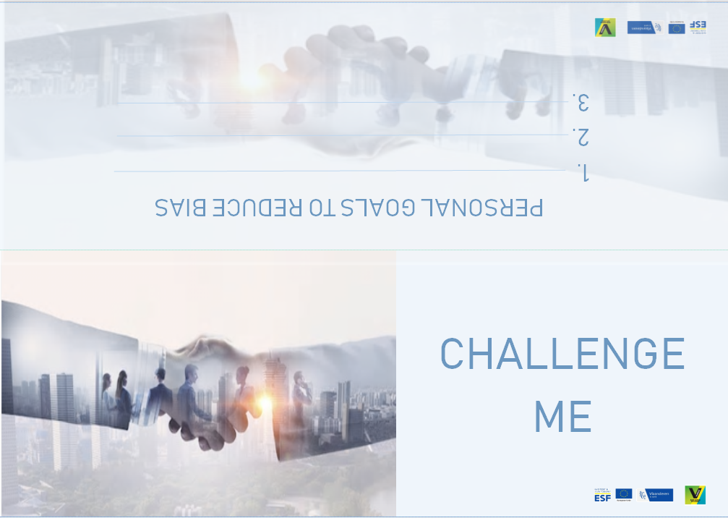

  - TESTIMONIAL CITY OF GHENT & PUBLIC CENTER FOR SOCIAL WELFARE GHENT

PRACTICAL GUIDELINES
Objectives | - Gaining insight in real business initiatives to get started with diversity initiatives
Target group | A team that wants to invest more in diversity and wants to get inspired by best practices of other companies
Number of participants | Divide the group into subgroups of +/- 4 people and conduct the discussion with the entire group
Duration | 15 minutes
Set-up | Material:  - Testimonial (cfr. Attachment I)

INSTRUCTIONS
When starting with diversity initiatives, companies can learn valuable lessons from each other. For this reason it’s important that companies share experiences, ideas, potential pitfalls,… with one another.
Read the case of City of Ghent & Public Center for Social Welfare Ghent (OCMW Gent) and try to distil best practices, opportunities to implement similar initiatives in your organisation, potential pitfalls,… Focus on what you can learn from this case.

DISCUSSION
Ask the group to share their takeaways.

ATTACHMENT I

Testimonial City of Ghent & Public Center for Social Welfare Ghent

The diversity action plan of the City of Ghent and the Public Centre for Social Welfare Ghent (OCMW) was brought to life in 2017. The plan focuses on different minority groups: people with a work disability, people of foreign origin, people aged 50+,… Our ultimate goal is to achieve a workforce that reflects the diverse society of Ghent: our service centres can only provide high-quality service if all layers of society are represented in our work teams.

Specific goals and actions
With regard to people with a migration background, our objective for 2020 is an inflow of employees of foreign origin that counts for 30% of our total inflow.
Several initiatives allow us to take steps in the right direction. For example, in our selection procedure we focus on the candidate’s competencies and try to avoid giving too much weight to diplomas and other culture-dependent criteria. Furthermore, the language used in our vacancies must be clear, simple and neutral. In addition, we regularly subject our selection methods to a critical evaluation: we screen the adverse impact of our tools to minimise bias towards certain groups.
We also organise meetings with civil society organisations that operate in Ghent. By doing so, we gather a lot of information from our target groups’ perspective. We also work closely with these organisations to advertise our open vacancies directly to our target groups.

Experiences so far
As a result of the diversity plan, our organisation is more consciously thinking about diversity and is more aware of the importance of diverse teams. We are all striving towards one common goal, which creates a sense of unity. Another

success story is the introduction of annual vocational trainings: paid internships
we offer to vulnerable job seekers in collaboration with VDAB. This year we offered vocational internships to 8 people of foreign origin and 2 people with a work disability. Overall reactions of line managers, colleagues and trainees were very positive.

Lessons learned
It is still difficult to determine the minimum language requirements. As a government agency, we are bound by language legislation: as all formal communication is in Dutch, every person who starts working with us must have a decent level of Dutch. However, we do not want to set our expectations too high and, as a consequence, miss talented people.

What advice do you have for other companies?
Developing and implementing a sound diversity plan costs time and must be coordinated by one or several dedicated employees who are working on diversity projects full time. That’s the only way to encourage the entire organisation to participate in our diversity initiatives. In addition, we have benefited a lot from engaging directly with our target groups through the civil society organisations. Gaining primary information is crucial to roll out a sustainable and effective policy that builds on mutual trust between the various stakeholders involved.
Naomi Mike, Organisational Psychologist, Department Selection, City of Ghent & Public Center for Social Welfare Ghent

MODULE 4

Managing diversity in the workplace

  - CODE OF CONDUCT
PRACTICAL GUIDELINES
Objectives | - Write a code of conduct based on dilemmas encountered by the company
Target group | A team that wants to clarify behavioural guidelines
Number of participants | Divide the group into subgroups of +/- 4 people and conduct the discussion with the entire group
Duration | 30 minutes
Set-up | Material:  - Template (cfr. Attachment I)  - Examples of dilemmas (cfr. Attachment I of leaflet 4.6. ; PowerPoint slides of the dilemmas can be found in appendix of the PowerPoint presentation of module 4)

INSTRUCTIONS
Making teams more diverse might increase the risk of encountering dilemmas. It’s important for a company to clarify how to deal with such dilemmas to avoid conflict and people feeling treated unfairly.
Can you think of dilemmas or difficult situations you encountered yourself?
Form subgroups of 4 people. Ask each group to define and discuss 5 dilemmas they encountered by bringing in more diversity in their teams. If people need help to come up with dilemmas, the trainer can use the predefined dilemmas in attachment of exercise leaflet 4.6.
Once every group defined/chose 5 dilemmas, create a guideline on how to handle similar future dilemmas. These guidelines must be linked to your company values.
Translate this to a code of conduct (=set of behavioural rules) for your company.

DISCUSSION
Ask each group to present their code of conduct.
Guiding questions to stimulate a group discussion are:
- Can this rule easily be implemented?
- Will this rule be well received by every department?
- How could you frame the implementation of the code of conduct?
- Is this rule fair for everyone?
- Does this rule matcher our company values?
- …

ATTACHMENT I

Code of conduct

Rule 1

Rule 2

Rule 3

Rule 4

Rule 5

Rule 6

Rule 7

  - DO’s AND DON’ts
PRACTICAL GUIDELINES
Objectives | - Create cross cultural awareness
Target group | A team that wants to understand cultural differences in daily behaviours
Number of participants | This exercise can be done individually  It’s also possible to divide the group into subgroups of +/- 4 people and conduct the discussion with the entire group  (cfr. Comment section)
Duration | 10 minutes
Set-up | Material:  - Template (cfr. Attachment I)
Comment | This exercise can be done in two different ways:  - For a multicultural team we advise to perform the exercise on an individual level. In this case, choose the countries of origin of the team members and compare these countries on daily behaviours. Each participant individually fills in the template, based on personal experience  - For a non-multicultural team we advise to perform the exercise in subgroups. Participants can visit the Hofstede website: (https://www.hofstede-insights.com/country-comparison/) and compare the countries’ scores on different cultural dimensions as a starting point of this exercise  - In general we advise to compare those countries with whom participants actually work together, adjust the template in attachment accordingly

INSTRUCTIONS
People for different cultures might have different habits in daily life. This shouldn’t be a problem at all. However, it’s important to know this differences and to be understanding towards one another. For some daily behaviours, such as greeting, guidelines can be included in the company’s code of conduct to minimise misunderstanding.
In the first column of the grid there are some daily behaviours. For each behaviour, write down 1 “do” and one “don’t” for the 3 countries. Please feel free to add more behaviours and countries.

DISCUSSION
Ask each group to present their do’s and don’ts.
Some guiding questions:
- What are the do’s and don’ts you encountered yourself?
- Have you ever worked together with someone who behaved this way? How did that feel?
- What could you do to overcome these differences?
- …

ATTACHMENT I
Behaviours | Belgium | Netherlands | Japan | …
Way of greeting | do | do | do
 | don’t | don’t | don’t
Informal communication | do | do | do
 | don’t | don’t | don’t
Decision making | do | do | do
 | don’t | don’t | don’t
Feedback giving | do | do | do
 | don’t | don’t | don’t
Handling emotions | do | do | do
 | don’t | don’t | don’t
Dealing with hierarchy | do | do | do
 | don’t | don’t | don’t

  - FLAWLESS FEEDBACK
PRACTICAL GUIDELINES
Objectives | - Giving constructive feedback
Target group | A team that wants to stimulate and improve its feedback practices
Number of participants | Divide the group into subgroups of +/- 4 people and conduct the discussion with the entire group
Duration | 20 minutes per case
Set-up | Material:  - Cases (cfr. Attachments I – VI of leaflet 4.5)

INSTRUCTIONS
Giving and receiving feedback is crucial for professional and personal development, but the way we like to give and receive feedback depends on culture. In some cultures being direct with feedback is highly appreciated while in others it’s considered polite to approach feedback more indirectly.
We will practice our feedback skills using two effective techniques: non-violent communication and SBI.
Let the participants read the case (choose 1 of the cases described in leaflet 4.5.) and assign two role players. For example, in the case of “Who even wants two bosses”: ask one participant to play Dan and to give feedback to Youssef regarding Tanya’s complaints. The participants who plays Dan should choose one of the two techniques to apply.

DISCUSSION
Ask the group how they experienced the role play.
Guiding questions to stimulate a group discussion are:
- Which technique was used?
- How did Youssef react to the feedback? How did he feel?
- What would you have formulated differently?
- How can you apply the two feedback techniques in your daily communication?
- …

  - I AM BUT I AM NOT
PRACTICAL GUIDELINES
Objectives | - Create cross cultural awareness
Target group | A team that wants to overcome cultural differences and stereotypes
Number of participants | Individual exercise  Discussion should be conducted with the entire group
Duration | 15 minutes per case
Set-up | Material:  - Template (cfr. Attachment I)

INSTRUCTIONS
The following exercise is a great way to break down misconceptions and stereotypes by allowing employees to report on how they identify themselves, while also allowing them to address the stereotypes behind these identifying factors.
Fill in the first blank with some kind of common identifier, such as your race, religion, etc. and the second with a common stereotype about that identifying group which does not apply to you (whether the stereotype is positive or negative). For example, “I am Asian, but I am not a big fan of rice.”

DISCUSSION
Ask the group to share their statements.
Funny statements are allowed, but guarantee a respectful discourse on stereotypes.

ATTACHMENT I
I Am But I Am Not
I AM | BUT | I AM NOT

  - ROLE PLAYS

PRACTICAL GUIDELINES
Objectives | - Discussing real-life situations of multicultural companies  - Taking different perspectives
Target group | A team that wants to build or strengthen its inclusive culture
Number of participants | Ideally 8 – 30 people  Exercise can be done with the entire group (appoint 2 role players, the rest of the group are observers)  It’s also possible to divide the group into subgroups of +/- 4 people (each group appoints 2 role players, others are observers) and conduct the discussion with the entire group
Duration | 20 minutes per case
Set-up | Material:  - Cases (cfr. Attachments I - VI)
Comment | Of course it also possible to work with real situations participants faced, instead of the predefined cases in attachment

INSTRUCTIONS
Building a diverse organisation often results in more rich, but also more complex daily situations and interactions.
To avoid misunderstandings between different actors, it’s important to try to see things from another’s perspective once in a while.
Below are some situations one might encounter working in a diverse team.
Ask the participants to read one of the cases. Once everyone has read the case, assign roles. Ask the others to observe the play, they can take notes.

ROLE PLAY
Participants take on the persona of their character and to play their role.
Observers take notes.
If the exercise is performed in the entire group, it’s recommended to split the group of observers in half (in case of 2 roles to play), with one group observing one character and the other half observing the other character.

DISCUSSION
Ask the group how they experienced the role play.
Guiding questions to stimulate a group discussion are:
- What happened during the play?
- How did the characters feel?
- Did you notice any misunderstanding?
- How did the character react to a certain phrase/question/statement?
- What would you have formulated differently?
- How will the situation continue?
- Did you ever face a similar situation in your own team? How did you deal with it?
- What can we learn from this role play?
- …

ATTACHMENT I

Case: A Matter of Perception (full version)

Ghada, a 30 years old Syrian woman, joined the administrative cell of an international pharmaceutical company 2 months ago. She works as administrative assistant for the Belgian division of the company.
The administrative team consists of 4 other assistants who have been working together for a long time and form a close group. The team likes to have lunch together in the company restaurant, where they jauntily discuss the novelties of the day.
However, Ghada does not join her colleagues for lunch. As she doesn’t really master the Dutch language, she doesn’t understand what they’re talking about and can’t participate in the conversations. She would love to join her team members and get to know them better, but doesn’t dare to. Her modest character holds Ghada back from asking her colleagues to talk in English instead of Dutch. She thinks that would be quite an impolite request as she does not want to force people to adapt to her individual needs.
The administrative team on the other hand, thinks Ghada is acting rude and uninterested. They interpret her behaviour as a clear sign of a lack of effort to integrate and decide to speak to their supervisor about Ghada’s “inappropriate behaviour”.

Role 1: What would you do if you were the supervisor of the administrative unit.
Role 2: What would you do if you were Ghada?

ATTACHMENT II

Case: A Matter of Perception (perspective role 1: Ghada)

Ghada, a 30 years old Syrian woman, joined the administrative cell of an international pharmaceutical company 2 months ago. She works as administrative assistant for the Belgian division of the company.
The administrative team consists of 4 other assistants who have been working together for a long time and form a close group. The team likes to have lunch together in the company restaurant, where they jauntily discuss the novelties of the day .
However, Ghada does not join her colleagues for lunch. As she doesn’t really master the Dutch language, she doesn’t understand what they’re talking about and can’t participate in the conversations. She would love to join her team members and get to know them better, but doesn’t dare to. Her modest character holds Ghada back from asking her colleagues to talk in English instead of Dutch. She thinks that would be quite an impolite request as she does not want to force people to adapt to her individual needs.
Ghada’s supervisor planned a 1to1 meeting for this afternoon. She thinks he might want to discuss this.

What would you do if you were Ghada?

ATTACHMENT III

Case: A Matter of Perception (perspective role 2: supervisor)

Ghada, a 30 years old Syrian woman, joined the administrative cell of an international pharmaceutical company 2 months ago. She works as administrative assistant for the Belgian division of the company.
The administrative team consists of 4 other assistants who have been working together for a long time and form a close group. The team likes to have lunch together in the company restaurant, where they jauntily discuss the novelties of the day .
However, Ghada does not join her colleagues for lunch. The administrative team thinks Ghada is acting rude and uninterested. They interpret her behaviour as a clear sign of a lack of effort to integrate and spoke to their supervisor about Ghada’s “inappropriate behaviour”.

What would you do if you were the supervisor of the administrative unit.

ATTACHMENT IV

Case: La Lingua Franca

Jack Bloomberg, an American from Chicago, moved to Ghent (Belgium) 2 years ago to reunite with his wife Betty. Betty obtained a PhD in Belgium in 2010 and stayed in Ghent to start a university spin-off.
The first year after his arrival, Jack focused on learning the national language: he took intensive Dutch classes to obtain a decent level of Dutch and got involved in some voluntary work.
Recently Jack decided to start looking for job in Belgium. After some months of writing resumes and cover letters, he was happy and relieved that S&H (a big player in the logistics sector, based in Ypres, West-Flanders) hired him as a change expert to manage a new project. The aim of this project is to implement a new software programme that will facilitate courier tracking. Jack’s role is to coordinate and harmonize the belongings of different stakeholders (at all levels of the organisation), to implement a new system and to analyse its effectiveness.
To legitimize Jack’s interference in this long-term change process and because not every member of the project team speaks English, he tries to communicate in Dutch as much as possible. Despite his efforts, Jack feels really insecure about his communication with the Belgian stakeholders. During presentations he notices that people are giggling because of his “very Dutch” accent. In one on one conversations he can’t translate the strong West-Flemish dialect to the Dutch he learned. In group discussions he totally gets lost in the mishmash of different Flemish accents and dialects, but doesn’t dare to ask to switch to English. He never talked about his frustrations and insecurities, neither to his direct supervisor, nor to his project team.

Role 1: What would you do if you were Jack?
Role 2: What would you do if you were Jack’s direct supervisor?

ATTACHMENT V

Case: Who even wants two bosses?

Youssef, a Moroccan engineer who has been in Belgium for 4 years, loves his job as a product designer for a multinational technology company headquartered in Brussels. Using his design skills and technical knowledge to improve the way products work and look, is what drives him. Moreover he gets along really well with his manager, Dan.
However, there’s one thing that has been frustrating him for several weeks now. The company decided to start a pilot program on cross-functional team structures. As a consequence Youssef now has an extra (functional) manager: Tanya.
Youssef finds it quite annoying that she asks him for information all the time and doesn’t like her “directive management style”. Consequently, he often postpones to answer her requests for information and even ignores some of her work instructions.
Tanya thinks Youssef is acting this way because he doesn’t accept female leadership and asks Dan to talk to Youssef about his behaviour.

Role 1: What would you do if you were Youssef?
Role 2: What would you do if you were Dan?

ATTACHMENT VI

Case: Nadia

Nadia is a 40 years old woman of Arabic origin and works for GL, a middle-sized company in the food industry. She has been working as an accountant for 3 years now and likes her job a lot.
Laila, GL’s head accountant and Nadia’s supervisor, is really pleased with Nadia’s work. During Nadia’s last performance appraisal interview, she told her she beliefs Nadia has a lot of growth potential to further develop herself. Also the other team members are convinced of Nadia’s good work and believe her skills are of great value to the team.
However, on a personal level, certain team members feel uncomfortable around her because Nadia is wearing a headscarf. They think it’s something weird and don’t understand why such a competent, smart woman would hide herself to please others or to please some “divine being”.
Nadia did notice that her colleagues have problems with her headscarf, but hasn’t talked to them about it yet.

Role 1: What would you do if you were Laila?
Role 2: What would you do if you were Nadia?

  - DILEMMA DEBATE

PRACTICAL GUIDELINES
Objectives | - Thinking about how you would deal with difficult situations  - Hearing insights about how others dealt or would deal with difficult situations  - Making sensitive issues open to discussion
Target group | A team that wants to build or strengthen its inclusive culture
Number of participants | Ideally 8 – 30 people
Duration | 45 minutes
Set-up | Material:  - Cards with dilemmas (cfr. Attachment I)  - PowerPoint slides of the dilemma can be found in appendix of the PowerPoint presentation of module 4  - Paper  - Pens

INSTRUCTIONS
One person takes a card and reads the situation.
Everybody writes down how he/she would deal with this situation (5 minutes).
Set some ground rules:

As we will share sensitive/confidential information, it is important to have some basic rules of engagement:
- Confidentiality: what is discussed, stays in the room. So please feel free to share how you dealt with a similar situation in the past, whether it turned out good or bad, because that way we can learn from each other’s successes or fails.
- Respect: respect each other’s opinion, give constructive feedback, support and challenge, ask questions but be respectful and unbiased. This also means that you really listen to each other, and that you’re not on your cell phone or laptop checking your messages.

DEBATES
Listen to everyone’s ideas and stimulate a constructive discussion between participants.
Once consensus is reached or no one wants to add new information, please take the next card. Agreement is not necessary, different opinions are valuable.
Continue until all the cards are discussed.

DISCUSSION
Ask each participant to note down one learning they take from this session.
Form a circle and let everyone share their learning in 1 minute.

ATTACHMENT I
Party Time

There is a teambuilding activity planned for next Friday. The day will be finished with a dinner and a little party. Talita, a new team member will help to organize the day. Talita’s religion prohibits consumption of alcohol. She says she has a problem with the fact that alcohol will be served that evening.

How do you deal with the situation?
Complicated Art

George’s screensaver shows an artwork of Michelangelo portraying a naked man. Axana is sitting next to George in the office and sees the picture often. Axana’s culture does not allow her to see naked men other than her husband. She wants George to change the picture but George refuses.

How do you deal with the situation?
Take it or Leave it

Bettina is wearing a burqa and applies for a job within your company. The policy of your company however does not allow to wear burqas for safety reasons. During the selection process Bettina explicitly says that she is not willing to take the burqa off.

How do you deal with the situation?
Happy New Year

Zi Ying asks you whether she can take one month off in February to go visit her family in China and celebrate Chinese New Year. In Chinese culture, it is an important holiday and it is an important moment to be with your family. Last year, she couldn’t make it, because she was in the middle of her new adventure in Europe. However, it is not common in your company to take a long holiday outside the summer months. And even in summer, there is an agreement that people do not take more than 21 days off in a row.
What do you say?
Ho Ho Ho

You work in an international company and are leading the committee tasked with organising and executing fun activities throughout the year. During the Christmas period, you arranged Santa Claus to come to the workplace and provided all employees with chocolate and Christmas cookies. Afterwards, you received the comment that this was not appropriate in an international environment.

How do you react?

Compris?

You work in an international company based in Belgium where English is used as a common business language. To make international employees feel welcome, everyone is requested to speak English. There is a department where only French people are working. They often speak French amongst each other (in the office or during lunch breaks).

How do you react as a team leader?
A Trip to Saudi Arabia

Patrick falls ill and because of this, he cannot accompany the CEO to a meeting in Saudi Arabia. A replacement needs to be found but it can only be a male colleague. Eva, who really wanted to go, lets you know this is unfair.

How do you react?
Ora et Labora

Bilal, who works already 1 year for your company, asks you if it is possible to have a prayer room in the company.

How do you react?
Say Hi

Your newly hired employee, Kaleb, refuses to shake hands with a woman due to respect for that woman.

What do you do?
Language Game

You work in an international company located in Flanders. Since many employees are from Flanders, colleagues often speak Flemish. Recently, a colleague was hired who only speaks English and no Dutch. This requires an effort from the employees to switch to English. The new colleague feels a bit guilty because they need to speak English especially for him. He doesn’t want to bother them too much, that’s why he doesn’t join them for lunch. His colleagues see this differently. They think their new colleague does not want to integrate within their team.

How would you handle this?

Hugs and Kisses

Kalila starts working for a company where people are greeting each other in a rather informal way, by kissing and hugging. Kalila does not feel comfortable about this.

How would you deal with this situation?
Lunch Time

Emir does not want to eat in the cafeteria of the company, because they serve pork. However, he is aware that lunch time is an important moment to get to know the colleagues in an informal way and since he is new in the company, he finds it extra important to have those moments with his colleagues. Since you are his supervisor, he comes to you and asks whether you have a solution.

What do you say?
What she Says

Ravi who is new in the company, does not accept orders from a woman. In meetings, he isn’t even listening when a woman is speaking.

What do you do?
A Social Event

The international employees within your company have no local friends. That’s why they start establishing an international community amongst them. They organise an event with international food at work and forget to invite the locals.

How would you deal with this situation?
Her Headscarf

Yasmine is working in the company for a couple of months now and she shows strong performance. You notice that 2 direct colleagues are sceptical about the fact that she’s wearing a headscarf. These colleagues exclude her from informal talks, and they even did not invite her to a team brainstorm.

How would you deal with this situation?
Social Talk

Marcella recently joined a team where she’s the first international. After a couple of weeks she indicates that she’s feeling lonely. She misses the more informal activities and social talk, which was part of the work culture in her country of origin.

How would you deal with this situation?
Shake Shake Shake

Ali recently joined a company where it’s common practice to shake hands, everytime someone arrives or leaves the office.
You notice that Ali does wants to shake hands with women.

How would you deal with this situation?
Weekend Work

Yonsha applied for the position of Lab Technician in a medical laboratory. The line manager is very convinced that she’s right for the job: she has the technical skills as well as a positive attitude. However, there’s one problem: during the interview she clearly stressed she does not want to work on Saturdays due to religious reasons.
Other team members follow a work schedule with Saturday work every three weeks.
How would you deal with this situation?
Ramadan

Mari applied for the open position in the operations team (which consists of 10 people). He’s suitable for the job, but he participates in Ramadan. As the operations team already has 2 employees who participate in Ramadan, the line manager fears hiring Mari would make the team schedule even more tricky than it already is.

How would you deal with this situation?
Tense Atmosphere

Ajwad and Tayeb are two employees of the same team. They do net get along at all, argue all the time and even physically fought each other once. Reason for their mutual hostility is their different origins: they’re descended from two rival Berber families.

How would you deal with this situation?

  - GINGER MAN
PRACTICAL GUIDELINES
Objectives | - Create a safe space to learn about each other’s (cultural) background and values  - Create an open setting to form bonds, increase empathy and improve relationships
Target group | Members of a cross-cultural team
Number of participants | Individual exercise  Discussion should be conducted with the entire group
Duration | 20 minutes individually  10 min sharing per person
Set-up | Material:  - Flipchart paper for every participants  - Markers in different colours  - Post-its  Location:  - Choose a spacious room

INSTRUCTIONS
This exercise is meant to get to know each other and to get more insight in each other’s background.
Since we will open up to each other it is important to have some basic rules of engagement:
- Confidentiality: what is discussed stays in the room. So please feel free to be open and honest, that way you can maximise what you get out of this session.
- Respect: respect each other, give constructive feedback, support and challenge, ask questions but be respectful and unbiased. This also means that you really listen to each other, and that you’re not on your cell phone or laptop checking your messages.
- Right to use ‘a joker’: you decide what you share and what you don’t share. If you feel a question is too personal or if you don’t want to elaborate on a certain part of the report, you don’t have to do so.
This creative exercise is about introducing yourself by a portrait, so only drawing: words, letters, numbers,… cannot be used. Drawing helps to activate your creative (right) brain half.
You have 20 minutes to draw your self-portrait: please use only images. Try to draw very detailedly and to provide a full picture of yourself. Do not stay on the surface but dig deeper. The good news is that you can tell what you have drawn once everyone has finished (so talking is not allowed during the drawing phase, but is after).
The self-portrait consists of (show the drawing):
- Head: when driving home or in the shower: what was going on in your head (private and professionally) last 2 weeks
- Heart: who or what is in your heart?
- Gut feeling: what is your core personality/where do your base decisions on? How would your best friends describe you? What is a typical value that defines your cultural background?
- Leisure: what do you do in your spare time?
- Professional background: what is the golden tread through your career, what thrives you in your profession?
- Past: what makes you the men/women you are today: in what kind of family did your grow up, what are slogans/values of your parents, what is your cultural/national background, life events, … ?
- Future/dreams: what will the future bring?

PRESENTATIONS
First present your own self-portrait as a means to create trust and an open mindset.
Let each participant present his/her portrait and tell their story. Invite others to ask extra questions and to be curious.

DISCUSSION
Ask each participant to note down on different post-its:
- One learning they take from this session
- One compliment for each other participant in the group
Let the participants stick the compliment post-its on the self-portraits of the others.
Form a circle and let everyone share their learning in 1 minute.

EXAMPLE
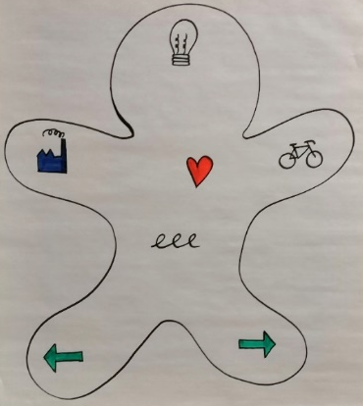

  - EMPATHY MAP
PRACTICAL GUIDELINES
Objective | Creating empathy for a new team member (of foreign origin)
Target group | A homogeneous team, that will soon welcome a first team member of foreign origin
Number of participants | Ideally 8 – 30 people
Duration | 25 minutes
Set-up | Material:  - Example of an empathy map (cfr. Attachment I)  - Post-its  - Pens

INSTRUCTIONS
Welcoming a new team member is always exciting and might even make you feel a bit tense or anxious. That’s completely normal. But have you ever thought about the newcomer’s feelings? Entering an existing group can also be very stressful. Especially when having a different background. This exercise helps you to imagine the event of entering our team through the newcomer’s eyes.
Draw the empathy map:
- Draw a large circle that is big enough to write some words in it
- Add eyes and ears to make it into a large ‘head’
Name the persona (newcomer’s name) and add the persona’s job title.
Label large areas around the head: “Doing”, “Saying”, “Thinking”, “Seeing”, “Hearing”, and “Feeling”.

EXERCISE
This person represents our new colleague who will soon join the team. Imagine you are *** (newcomer’s name).
What is he/she doing?
- What does he/she do to prepare for his/her first day at work?
- What is his/her morning routine?
- Did his/her behaviour change since he/she knows he/she will join us?
- …
Write all answers down on post-its and stick them to the right place on the empathy map.
What is he/she saying?
- What is he/she talking about?
- What does he/she tell others about his/her new job?
- …
Write all answers down on post-its and stick them to the right place on the empathy map.
What is he/she thinking?
- What is he/she thinking about?
- What are his/her positive thoughts?
- What are his/her negative thoughts?
- What is this person’s biggest fear?
- …
Write all answers down on post-its and stick them to the right place on the empathy map.
What is he/she seeing?
- What is he/she encountering in his/her daily experiences?
- What are the people around him/her doing?
- What is he/she watching/reading?
- Doe he/she understand everything he/she sees?
- …
Write all answers down on post-its and stick them to the right place on the empathy map.
What is he/she hearing?
- What is he/she hearing in his/her daily experiences?
- What are recurrent messages he/she hears?
- Doe he/she understand everything he/she hears?
- …
Write all answers down on post-its and stick them to the right place on the empathy map.
What is he/she feeling?
- How is he/she feeling?
- What makes him/her feel good?
- What makes him/her feel bad?
- What keeps him/her up at night?
- What does this person want?
- What drives this person?
- What makes this person happy?
- …
Write all answers down on post-its and stick them to the right place on the empathy map.

DISCUSSION
Form a circle where everybody shares how they have experienced this exercise and what they have learned.
Some guiding questions:
- What are differences in supposed behaviour/thoughts/feelings/…?
- What are similarities in supposed behaviour/thoughts/feelings/…?
- What can we do to make him/her feel at ease at his/her first day?
- …

ATTACHMENT I
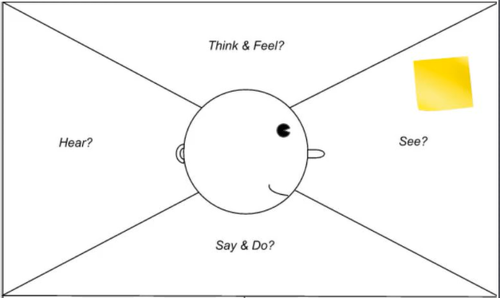

Contact us

,;
